DEFECT MANAGEMENT (LEVEL 5)
- Defect Management Concepts
- Defect Linking in TestRail
- Integration with Jira / Other Tools
- Defect Traceability

1. Defect Management Concepts :
A defect (bug) is a deviation between expected and actual behavior. In testing terms: Expected Result ≠ Actual Result
Defect Lifecycle :
New → Open → In Progress → Fixed → Retest → Closed
↓
Rejected / Deferred

Defect Management Matters because it helps to :
- Prevents defect leakage to production
- Enables prioritization
- Improves product quality
- Provides accountability
Defect management is risk management, not just bug tracking.

Roles Involved :
Role | Responsibility
Tester | Detect & report
Developer | Fix
Lead | Triage & prioritize
Product Owner | Accept / defer

2. Defect Linking in TestRail :
Defect Linking answers:
- Which test failed?
- Why did it fail?
- Is it fixed?
- Was it retested?
Defects are linked at execution level, not test case design level. Defects are linked to execution results, not to test cases directly.

Test Run → Test Case → Result
- Multiple defects per test
- Same defect linked to multiple tests
- Auto-linking with integrations
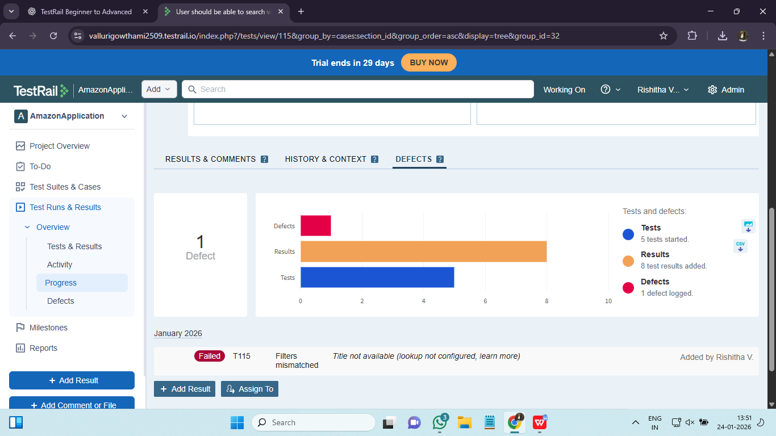

3. Integration with Jira / Other Tools :

Without integration (Jira) :
- Manual copy-paste
- No sync
- Tracking gaps
With integration (Jira) :
- Click-to-create defects
- Real-time status sync
- Full traceability

TestRail–Jira Integration Works :
Failed Test → Create Jira Bug → Link back to TestRail
Integration makes TestRail the single source of truth for testing, while Jira remains the system of record for defects.

Other Tools Supported :
- Azure DevOps
- Bugzilla
- YouTrack

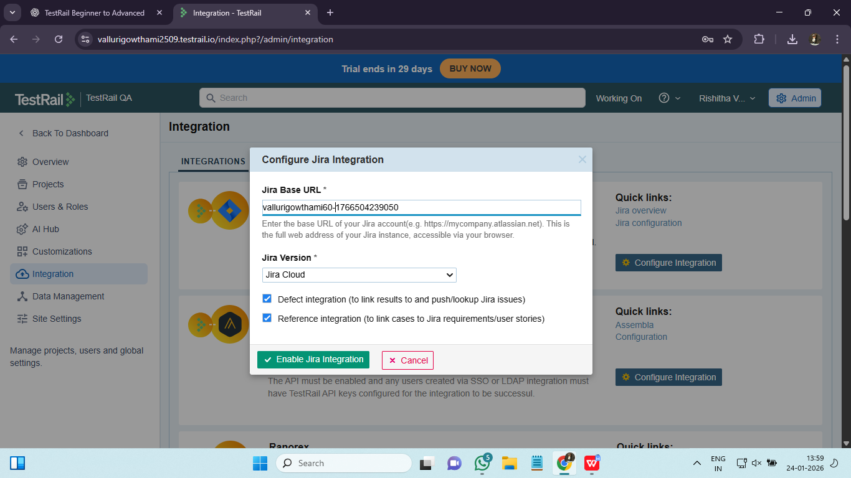

4. Defect Traceability
Defect traceability tracks:
Defect → Test Case → Execution → Requirement → Release
Defect traceability converts raw failures into actionable quality intelligence.

Defect Traceability is Critical because :
- Identify high-risk modules
- Measure quality trends
- Support audits
- Improve future testing

Traceability Flow :

Requirement
↓
Test Case
↓
Test Run
↓
Execution Result
↓
Defect
↓
Fix & Retest

Traceability Reports in TestRail :
- Defects per run
- Defects per requirement
- Defect density
- Reopen rate

